



**Voting with a Difference**



**The 2019 general election for voters who require support**

## Eviance Team Members

Dr. Susan L. Hardie   
Executive Director

Dr. Cameron Crawford   
Senior Research Officer

Evan Wicklund   
Research Officer

## Suggested Citation

Crawford, C., Hardie, S., & Wicklund, E. (2019). V*oting with a difference:   
The 2019 general election for voters who require support.* Winnipeg:   
Canadian Centre on Disability Studies Incorporated operating as Eviance.

## Sharing Guidelines

It is the hope of Eviance that the findings outlined in this report are used to inform policy and practice and improve inclusivity of persons with disabilities in society both in Canada and abroad.

Please acknowledge Eviance in the following ways:

* When referring to the report in published articles, PowerPoint presentations, websites, signage or other presentations use the proper citation above; and,
* This product and content included in it may not be used for commercial purposes.

This publication is a resource of Eviance. Elections Canada has engaged Eviance to deliver this publication for the 2019 federal election.

**Table of Contents**

Welcome! 4

Who is this booklet for? 4

Some basic facts about the federal election 6

What does it mean to register to vote? Why do I need to register? 9

Why should I register BEFORE I go to vote? 10

Ways to register to vote in a federal election 12

What is the Voter Information Card? 15

What do I need to bring with me to vote? 16

Have your ID ready to vote 17

Confirm your place of residence 19

Accepted ID 20

What are the different ways to vote? 22

Do I use a Regular Ballot or Special Ballot? 23

How do I vote on election day? 24

What to expect? 25

Things to consider if you vote on election day 26

How do I vote on advance polling days? 28

How do I vote at an Elections Canada office, including a Vote on Campus office? 30

Voting at an Elections Canada office 32

Things to consider if you vote at an Elections Canada Office: 33

How do I vote by mail if I can’t get to a polling station or Elections Canada office? 35

None of these ways to vote will work for me. Are there any other ways to vote? 37

What accessibility tools and services are available for me? 39

Bringing my own supports for voting 42

How do I make a plan to vote? 44

How do I find more information about voting? 47

How do I find more information about accessibility and elections? 48

How do I contact Elections Canada? 49

Key terms 50

# Welcome!

#### This straightforward guide is to help you register and vote at the 2019 federal election.

# Who is this booklet for?

#### Illustration of a person with arms outstretchedIt’s for anyone who is a Canadian citizen, 18 years of age or older and who wants to vote in a federal election. It has important details for you if:

You need an accessible polling station or other support to vote

Even an accessible polling station won’t be the right option for you

 You won’t be able to get to a polling station

You provide support to someone who has faced barriers to voting in the past or who will need some support so they can vote in the upcoming general election

#### This booklet has information for you if you have difficulty:

Being out and about in public

Getting into or moving about within buildings

Grasping and using small objects like a pencil

Hearing or understanding what others are saying

to you

Concentrating or following instructions

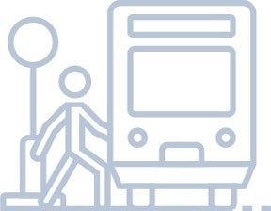If you have other difficulties that affect your ability to do everyday activities.

Standing in lineups without sitting to rest

Seeing or reading everyday printed materials, like magazines or newspapers

Printing, writing or putting a mark on a piece of paper

Remembering people’s names or faces

Dealing with unfamiliar people, places or routines

# Some basic facts about the federal election

In a federal election, Canadians vote to elect a candidate to be their member of Parliament (MP) and represent them in the House of Commons. MPs debate and pass laws on Canadians’ behalf.

One MP represents the people of one riding. There are currently 338 ridings in Canada. Therefore, there are 338 elected MPs.

Candidates can represent a political party, or they can be independent, meaning they have no association with a political party. After all the votes are counted for each riding, the political party with the most MPs in the House of Commons usually forms the government. The leader of that party becomes the prime minister of Canada.

To learn about federal elections, check out [**Step 1: Build or refresh your**](http://inspirerlademocratie-inspiredemocracy.ca/act/regist/rgvot/index-eng.asp#point1)[**knowledge about federal elections**](http://inspirerlademocratie-inspiredemocracy.ca/act/regist/rgvot/index-eng.asp#point1)in the Inspire Democracy Elector’s   
Guidebook to Registering and Voting. You may also want to read about federal   
elections on [**this page of the Elections Canada website**](https://www.elections.ca/content2.aspx?section=faq&amp;document=fedelect&amp;lang=e)**.**

## Why vote?

Voting is the way you will choose someone to represent you in Canada’s Parliament. That person will make decisions about issues that affect you and your community. By expressing your choice, you are exercising a right that is key to the democratic process of government that generations of Canadians have fought to build.

The federal government has its own areas of responsibility. These include:

The Canadian economy overall

Regulation of the banking system

International trade Relations between provinces and territories

Indigenous lands and rights

Relations with other countries

Taxation

Immigration

Public defense

The federal government also gives some money to provinces and territories to spend on health care, post-secondary education, support for children, job training and other social programs and public services.

To answer questions about how voting and elections work and why you should vote, check out this [**guide to voting created by ABC Life Literacy**](https://abclifeliteracy.ca/civic-literacy).

## Who can vote in a federal election?

You can vote in a general election if you:



Are a Canadian citizen

Are 18 years of age or older on election day

Can prove your identity and address

## Who can I vote for?

When you vote, you choose which candidate you want to speak for you in the House of Commons. A candidate is a person who is running for an elected position. Often this person is a member of a political party, which is a group of people who have the same vision about how the country should be governed.

During an election, you’ll be able to find information about your candidates through Elections Canada’s [**Voter Information Service**](https://www.elections.ca/scripts/vis/FindED?L=e&amp;PAGEID=20). If your candidate has a website, it will be listed here.

For information on how to find your candidates, check out [**Step 2: Learn about the candidates**](http://inspirerlademocratie-inspiredemocracy.ca/act/regist/rgvot/index-eng.asp#point2) in the *Inspire Democracy Elector’s Guidebook* for Registering and Voting.

# What does it mean to register to vote? Why do I need to register?

You need to be registered with Elections Canada to vote in a federal election. Registering to vote is letting Elections Canada know who you are and where you live so that you are voting in the right riding, and you are only voting once.

* If you voted in the last general election and haven’t moved, you’re probably registered.
* If you’ve never voted before, moved since the last general election, or are living away from home, you may need to register or update your voter information.

You do not need to register every time there is a federal election. Once the election is called, it is a good idea to check if you are registered, and to make sure your address information is up to date.

All registered electors will get a voter information card in the mail about two weeks before election day. It tells them where and when they can vote.

# Why should I register BEFORE I go to vote?

You must be registered to vote. You can register before you go to vote or at the same time as when you go to vote. Here are some reasons why you may want to register before you go to vote:

1. It will be quicker for you to vote if you are already registered. Save time on election day by making sure you’re registered ahead of time.
2. If you’re registered, Elections Canada will mail you a voter information card after the election has been called. This card tells you where and when you can vote and how accessible your polling station is. This card can be used as one of two pieces of ID you need to vote. If you are not registered before you vote or if your address information is wrong, you won’t receive one of these cards.

## I don’t know if I am registered or if my



## registration is up to date. How do I check?

#### Are you registered to vote?

### YES

You’ll receive a voter information card in the mail that tells you where and when you can vote.

### NO / DON’T KNOW

Visit [**elections.ca**](https://www.elections.ca/content2.aspx?section=reg&amp;document=index&amp;lang=e) or call 1-800-463-6868 to register

or update your voter information. You can also register when you go to vote.

If you are not sure if you are registered to vote, or if you don’t know if your registration is up to date, you can call Elections Canada at

1-800-463-6868 or 1-800-361-8935 (TTY) or you can check online through Election Canada’s [**Voter Registration Service**](https://ereg.elections.ca/CWelcome.aspx?lang=e).

#### For more on registering to vote:

1. [**Watch this video**](https://www.elections.ca/content2.aspx?section=spr&amp;dir=reg&amp;document=inscvid&amp;lang=e) to learn more about how to register to vote ([**version with ASL**](https://www.elections.ca/content2.aspx?section=spr&amp;dir=reg&amp;document=inscvid_asl&amp;lang=e))
2. [**Step 3: Make sure you are registered to vote**](http://inspirerlademocratie-inspiredemocracy.ca/act/regist/rgvot/index-eng.asp#point3) in the *Inspire Democracy Elector’s Guidebook* has more information about registering to vote.

## What if I know I’m *not* registered to vote?

If you know you are not registered to vote, there are lots of ways to register. You can register before you go to vote or when you go to vote.

##### 

**11**

**Voting with a Difference**

# Ways to register to vote in a federal election



## Register before you go to vote

### Online

Visit [**elections.ca**](https://www.elections.ca/content2.aspx?section=reg&amp;document=index&amp;lang=e) and use the [**Voter Registration Service**](https://www.elections.ca/content2.aspx?section=reg&amp;document=index&amp;lang=e)

to register or update your voter registration.

## Register when you go to vote

### At any Elections Canada office across Canada

Go to any Elections Canada office before the Tuesday

before election day, 6:00 p.m. Make sure to bring accepted ID.

### At your assigned polling station

Go to your assigned polling station on election day or advance polling days. Make sure to bring accepted ID.

**12**

**Voting with a Difference**

## How do I register online?

To register online, you can use the [**Voter Registration Service**](https://ereg.elections.ca/CWelcome.aspx?lang=e) at [**elections.ca**](https://www.elections.ca/content2.aspx?section=reg&amp;document=index&amp;lang=e). Use this online service to register to vote, check your registration, or update your address information.

If you plan to register online, here are some things to think about first:

1. There will be a lot of text to read on the screen. If this is likely to be difficult for you, you may want to ask someone for help.
2. Have your address information ready. You will be asked to put your address into the online form. If you live in a remote or rural area, or if you have an irregular address, it may not fit easily into the form.
3. Once you have entered your information into the form, you will be taken to a review page to confirm this information. Here, you will need to type a security code into a text box. This security code is written in script and may be difficult to read. If you can’t see this number, you can listen to an audio recording. You may find it helpful to ask someone you trust to help you read the security code and enter it into the text box.
4. You may need to give one or two pieces of identification (ID) if you are registering to vote for the first time.

When you register online, you may be asked for the number from:

1. Your driver’s license from any province or territory except Quebec; or
2. Your provincial or territorial ID card (if you live in Alberta, Newfoundland and Labrador, Saskatchewan or Yukon)

If you do not have either of these forms of ID, you can use the [**Online**](https://ereg.elections.ca/eFAQ.aspx#faq6)[**Document Submission**](https://ereg.elections.ca/eFAQ.aspx#faq6) feature on the Voter Registration Service.

You will need two pieces of ID from this [**online list**](https://www.elections.ca/content2.aspx?section=id&amp;document=index&amp;lang=e). See also the chart, **Accepted ID (on page 20)**. Both pieces of ID must show your name,   
and at least one must show your address. Some examples of ID you can   
use include:

1. Health card and credit card statement
2. Public transportation card and label on a prescription container
3. Identity bracelet issued by a hospital or long-term care institution and CNIB card
4. Government statement of benefits and letter of confirmation of residence, letter of stay, admission form or statement of benefits from a long-term care institution

Not everyone is comfortable registering online. You can ask someone to help you, or you can register in-person.

## Can I still vote if I did not register before?

Yes! You can register at the same time as you go to vote. Remember: Registering when you go to vote at your polling station may take a bit more time. Keep this in mind when you make your plan to vote.

# What is the Voter Information Card?

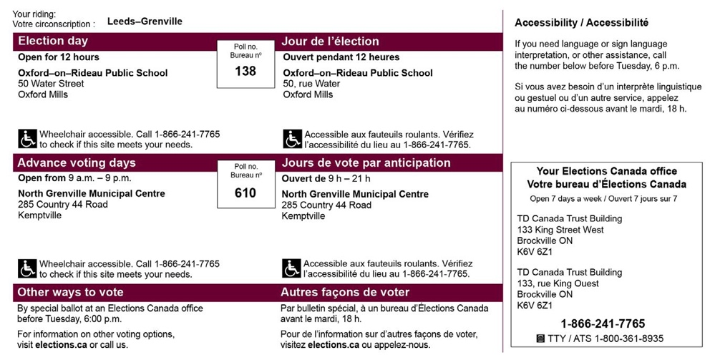

Shortly after the election has been called and if you are registered to vote, Elections Canada will send you a Voter Information Card in the mail. Your card will show your name and address and will look like the image above.

## The Voter Information Card:

1. Tells you where and when you can go to vote.
2. Tells you about the physical accessibility of the place where you will vote with an accessibility symbol. It will either tell you that your polling station meets all 15 of Elections Canada’s accessibility criteria, or that it is wheelchair accessible (that means the building has an entrance door that is wide enough for a wheelchair and has level access or a ramp to the entrance). Or, it may let you know that your polling station does not have wheelchair access.
3. Helps speed up voting — it’s a good idea to bring the card with you when you vote.
4. Can be used as one of two pieces of ID to vote.

If your voter information card doesn’t show an accessibility symbol for your polling station, or you aren’t clear whether the polling station will be able to meet your needs, you can call your Elections Canada office to find out using the telephone number on your voter information card. You can also find this number by entering your postal code into Elections Canada’s online   
[**Voter Information Service**](https://www.elections.ca/scripts/vis/FindED?L=e&amp;PAGEID=20).

# What do I need to bring with me to vote?

When you go to vote, you will need to prove who you are and where

you live. To do this, you will need to bring some identification (ID).   
There are [**a few different ways**](https://www.elections.ca/content2.aspx?section=id&amp;document=index&amp;lang=e) you can use ID to prove who you   
are and where you live.

# Have your ID ready to vote



#### Three options to prove your identity and address

## Option 1 — Show one of these pieces of ID

* + Your driver’s licence
  + Any other card issued by a Canadian government (federal, provincial/territorial or local) with your photo, name and current address

## Option 2 — Show two pieces of ID

Both must have your name and at least one must have your current address

### Examples:

* + Voter information card and bank statement
  + Utility bill and student ID card

### Don’t have these? No problem!

There are other pieces of accepted ID. Check out the full list at [**elections.ca**](https://www.elections.ca/content2.aspx?section=id&amp;document=index&amp;lang=e).

## Option 3 — If you don’t have ID

You can still vote if you declare your identity and address in writing and have someone who knows you and who is assigned to your polling station vouch for you.

The voucher must be able to prove their identity and address. A person can vouch for only one person (except in long-term care institutions).

**17**

**Voting with a Difference**

## Things to consider when choosing what piece of ID to bring:

* You can bring original ID cards or documents, including statements or invoices you may receive electronically
* If you are using electronic documents, you can print them or you can show them on your mobile device.
* You can use expired pieces of ID.
* You can use two pieces of ID from the same source as long as the documents are for different things. Example: an invoice and a transcript from the same school.
* You can use your up to date voter information card to prove your address. You will still need another piece of ID with your name.
* For a piece of ID to be accepted, your name and/or address must be printed on the document. They can’t be added by hand unless they are added by the issuer of the document, like a residence administrator. For example, a current or expired Canadian passport may be used as a proof of identity (your name) but not as a proof of address, because the passport holder writes their current address by hand in the passport.

Some people may have trouble proving their address. If you live in or receive services from any of these places, you can ask for a letter of confirmation of residence. This includes

* A long-term-care institution
* A community-based residential facility
* A seniors’ residence
* A student residence
* A shelter or soup kitchen
* A First Nations band or reserve
* An Inuit local authority

**Voting with a Difference**

**18**

## If you need a letter of confirmation of residence:



Contact the place as soon as possible after the election is called. They may issue a letter of confirmation on their official letterhead or use the Elections Canada template [**Letter of Confirmation of Residence**](https://www.elections.ca/vot/ids/EC50053_e.pdf).

You will need to show a second piece of ID with your name.

# Confirm your place of residence

Your place of residence or home address is where you ordinarily live, where you think of as home or have adopted as home.

## Temporary absence

If you leave your home temporarily (for school, work or any other reason)   
but intend to return to it, it can remain your place of residence.

Once you’ve decided on your place of residence, bring ID with that address when you go to register and vote.

**19**

**Voting with a Difference**

# Accepted ID

Here’s a full list of accepted ID. [**Click here for a printable list**](https://www.elections.ca/id/idLangs/EC90189_e.pdf).

|  |  |
| --- | --- |
| **From a government or government agency** | |
| * Band membership card * Birth certificate * Canadian citizenship card or certificate * Canadian Forces identity card * Canadian passport * Card issued by an Inuit local authority * Firearms licence * Government cheque or cheque stub * Government statement of benefits * Health card * Income tax assessment * Indian status card or temporary confirmation of registration | * Library card   Licence or card issued for fishing, trapping or hunting   * Liquor identity card * Métis card * Old age security card * Parolee card * Property tax assessment or evaluation * Public transportation card * Social insurance number card * Vehicle ownership * Veterans Affairs health care identification card |

|  |  |
| --- | --- |
| **From Elections Canada** | **From an educational institution** |
| * Targeted revision form to residents of long-term care institutions * Voter information card | * Correspondence issued by a school, college or university * Student identity card |

|  |  |
| --- | --- |
| **From a health care facility or organization** | **From a financial institution** |
| * Blood donor card * CNIB card * Hospital card * Label on a prescription container * Identity bracelet issued by a hospital or long-term care institution * Medical clinic card | * Bank statement * Credit card * Credit card statement * Credit union statement * Debit card * Insurance certificate, policy or statement * Mortgage contract or statement * Pension plan statement * Personal cheque |

|  |  |
| --- | --- |
| **From a private organization** | **Letters of confirmation** |
| * Employee card * Residential lease or sub-lease * Utility bill (e.g.: electricity; water; telecommunications services including telephone, cable or satellite) | * Letter from a public curator, public guardian or public trustee * Letter of confirmation of residence from   a First Nations band or reserve or an Inuit local authority   * Letter of confirmation of residence, letter of stay, admission form, or statement   of benefits from one of the following designated establishments:   * Student residence * Seniors’ residence * Long-term care institution * Shelter * Soup kitchen * A community-based residential facility |

# What are the different ways to vote?



#### You can vote almost any time during the election period using one of the many different ways to vote. You can choose the way to vote that works best for you.

## Ways you can vote in the federal election

### On election day

Check your voter information card or visit [**elections.ca**](http://elections.ca/)

to find out where your assigned polling station is located.

### On advance polling days

Can’t vote on election day? You can vote in advance at your assigned polling station. Check your voter information card or visit [**elections.ca**](http://elections.ca/) to find out where to go.

### At any Elections Canada office across Canada

Visit [**elections.ca**](http://elections.ca/) to find the Elections Canada office nearest you. You will vote using the special ballot process. Deadlines apply. Check your voter information card or visit [**elections.ca**](http://elections.ca/) to find out where to go.

### By mail

Visit [**elections.ca**](http://elections.ca/) to find out more. Deadlines apply.

##### Voting with a Difference 22

# Do I use a Regular Ballot or Special Ballot?

Depending on which way you choose to vote, you will use either a regular ballot or a special ballot to cast your vote. Both of these ballots are secret, which means that no one except you will know who you vote for.

## Regular Ballot

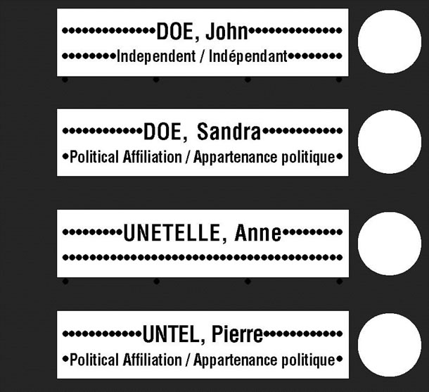

A regular ballot is a piece of paper that shows the candidates’ names and political parties, if they are running with one. There is a circle beside each name. You will use the regular ballot to vote if you vote on election day, at advance polls, or at a mobile poll. You will use the regular ballot to vote at an Elections Canada office or if you vote at home once the list of candidates is confirmed, which is two weeks before election day. The regular ballot looks like the image below.

## Special Ballot

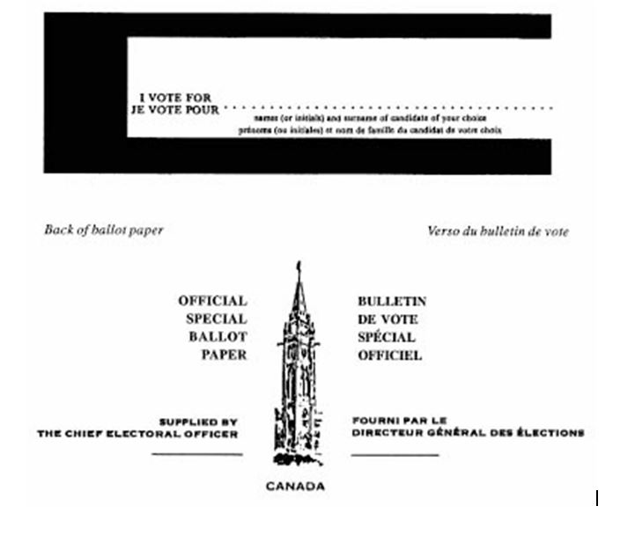

A special ballot is a piece of paper with a space where you write the name of the candidate you want to vote for. The

candidates’ names and political parties are not already printed on the ballot. You will use the special ballot to vote by mail. You will also use the special ballot if you vote at an Elections Canada office or if you vote at home earlier than two weeks before election day. The special ballot looks like the image below.

# How do I vote on election day?

## Why:

Most Canadians will vote on election day at their assigned polling station. If you are working on election day, the law says your employer must give you three hours in a row to vote. [**Use this link for more information**](https://www.elections.ca/content2.aspx?section=faq&amp;document=faqtimo&amp;lang=e) about taking time off to vote.

## Where:

You vote at your assigned polling station in your community based on where you live. Check your voter information card for:

* the location of your polling station, the place where you can vote
* the date of election day
* the hours when you can vote on election day
* details about the accessibility of your polling station

## When:

Your assigned polling station will be open for 12 hours

(these hours will depend on which province and territory you live in).

# What to expect?

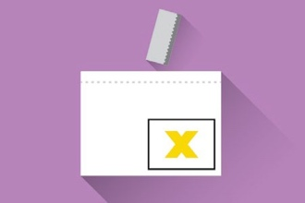

## Voting at your assigned polling station

An election worker greets you and shows you to the right table. If you need help, ask an election worker.

Show your proof of identity and address.

An election worker checks your name on the list of electors and gives you a folded ballot.

Go behind the voting screen, mark your ballot and refold it to keep it secret.

Return your ballot to the election worker. They will remove the tab so that your ballot can’t be traced back to you.

Put your ballot in the ballot box.

##### Voting with a Difference 25

# Things to consider if you vote on election day

1. You’ll be voting with a regular ballot, which means the names of the candidates in your riding will be listed on the ballot. You will make a mark in the circle beside the name of the candidate you want to vote for. This mark could be any kind of mark, as long as it clearly shows which candidate you are voting for. Put a mark in one circle only.
2. Most Canadians will vote on election day. That means you may have   
   to wait in line to vote. Keep this in mind when you make your plan to vote. **See page 44** about making your plan.
3. Make sure your polling station meets your accessibility needs.

Check your voter information card, call Elections Canada

(1-800-463-6868 or 1-800-361-8935 [TTY]) or check online through the [**Voter Information Service**](https://www.elections.ca/scripts/vis/FindED?L=e&amp;PAGEID=20) to see if your polling station will be accessible for you.

1. Elections Canada has 15 mandatory accessibility criteria for all polling stations (**see chart on page 2****7**).
2. If your assigned polling station doesn’t meet your accessibility needs, or if you live in a community where there is no polling station within a reasonable distance from your home, call the Elections Canada office in your riding or 1-800-361-8935 (TTY). You may apply for a transfer certificate so you can vote at another polling station in the same riding. Elections Canada will help you find an alternate polling station or discuss other ways you may be able to vote.
3. Check the section — **How do I make a plan to vote?** —

for more things to consider as you choose which way to vote.

## Elections Canada’s standards to make polling stations accessible

|  |
| --- |
| **Building exterior** |
| * The surface of the pathway to the exterior entrance is firm and obstacle-free. * The pathway is at least 920 mm (36 inches) wide. * The building provides a level access to the entrance. * There is exterior building lighting. * The exterior of the building is free of any protruding objects. |

|  |
| --- |
| **Building entrance** |
| * The exterior door has a clear opening width of 810 mm (32 inches). * The door threshold meets a maximum standard of 6 mm (1/4 inch). * The weight of the entrance door allows it to be easily opened. |

|  |
| --- |
| **Building interior** |
| * The interior door(s) have a clear opening width of 810 mm (32 inches). * The weight of the interior doors allows them to be easily opened. * The interior door threshold meets a maximum standard of 6 mm (1/4 inch). * Corridors have a maximum width of 920 mm (36 inches) * The interior of the building is free of any protruding objects. * The voting room is on the same level as the entrance. * The interior lighting works. |

# How do I vote on advance polling days?

## Why:

If you don’t think you will be available to vote on election day, or if you want to vote before election day, then one of the ways you can vote is at an advance poll. You may choose to vote at the advance polls because you want to avoid waiting in election day lines, or because you are more familiar with your advance polling station location than your election day polling station.

## Where:

You vote at your assigned advanced polling station in your community based on where you live. It might be the same polling station you would vote at on election day, or it might be a different one. Check ahead of time to make sure you’re heading to the right polling station: you can find this information on your voter information card or online at the [**Voter Information Service**](https://www.elections.ca/scripts/vis/FindED?L=e&amp;PAGEID=20).

## When:

There are four days of advance polls. Your assigned polling station will be open from 9 a.m. to 9 p.m. on the Friday, Saturday, Sunday and Monday the week before election day.

## What to expect:

The voting process on advance polling days is the same as for voting on election day. (See the chart **on page 2****7**).

## Things to consider if you vote on advance polling days:

1. The list of candidates in braille is only available on election day. If you will need assistance reading the ballot, you can ask an election worker, bring someone with you, or you can bring your own electronic device (like an e-reader).
2. You’ll be voting with a regular ballot, which means the names of the candidates in your riding will be listed on the ballot. You will make a mark in the circle beside the name of the candidate you want to vote for. This mark could be any kind of mark, as long as it clearly shows which candidate you are voting for. Put a mark in one circle only.
3. More and more Canadians choose to vote on advance polling days. That means you may have to wait in line to vote. Keep this in mind when you make your plan to vote. **See page 44** about making your plan.
4. Make sure your advance polling station meets your accessibility needs. Check your voter information card, call Elections Canada

(1-800-463-6868 or 1-800-361-8935 [TTY]) or check online through the [**Voter Information Service**](https://www.elections.ca/scripts/vis/FindED?L=e&amp;PAGEID=20) to see if your polling station will

be accessible for you.

1. Elections Canada has 15 mandatory accessibility criteria for all polling stations (**see chart on page 27**).
2. If your assigned advance polling station doesn’t meet your accessibility needs, or if you live in a community where there is no advance polling station within a reasonable distance from your

home, call the Elections Canada office in your riding or 1-800-361- 8935 (TTY). You may apply for a transfer certificate so you can vote at another polling station in the same riding. Elections Canada will help you find an alternate polling station or discuss other ways you may be able to vote.

1. Check the section – **How do I make a plan to vote?** –

for more things to consider as you choose which way to vote.

# How do I vote at an Elections Canada office, including a Vote on Campus office?

## Why:

If you want to vote in person but not on election day or at advance polls, you can vote at an Elections Canada office. Anyone can vote at an Elections Canada office. Some reasons you may choose to vote at an Elections Canada office include:

* You want to avoid waiting in long lines,
* You want to take your time voting,
* An Elections Canada office is easier for you to access than your polling station

## Where:

Once the election has been called, there will be over 500 Elections Canada offices set up across the country. Every riding in Canada has an Elections office. Visit [**elections.ca**](https://www.elections.ca/home.aspx) to find the office nearest you.

You can also vote at an Elections Canada Vote on Campus office. These are Elections Canada offices that are set up on some school campuses across the country for five days about two weeks before election day. These Vote on Campus offices are made for students, but any elector can register and vote at these locations.

## When:

You can vote at any Elections Canada office by the Tuesday before election day at 6 p.m. Elections Canada offices are open 7 days a week once the election has been called.

## What to expect:

Voting at an Elections Canada office or Vote on Campus office is different than voting on election day or advance polling days.

# Voting at an Elections Canada office

#### Voting at an Elections Canada office is different than voting on election day or advance polling days. Here, you will vote using the special ballot process.

**1 2 3**

An election worker will greet you at the counter and ask for proof of identity and address.

**4**

The election worker will add, update or confirm your information and ask you to verify it on the computer screen.

**5**

You will be given a ballot and instructions. Ask for the list of candidates for your riding if you need it.

**6**

Go behind the voting screen, mark your ballot and return to the election worker.

**7**

The election worker will give you two envelopes.

**8**

First, put the ballot in the unmarked inner envelope and seal it. Then, put that envelope in the outer envelope and seal it.

Read the declaration on this outer envelope and sign it.

Put your envelope in the ballot box.

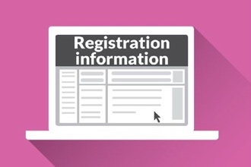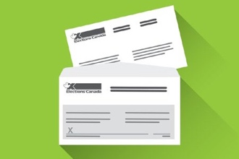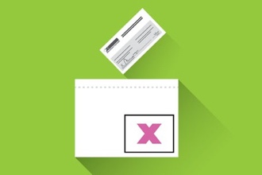

##### Voting with a Difference 32

**Keeping your vote secret**

When it’s time to count the ballots, the election worker will remove all the unmarked inner envelopes from their signed outer envelopes. The election worker will then return only the unmarked inner envelopes to the ballot box and mix them up. This way, no envelope can be traced back to the voter and your vote remains secret.

# Things to consider if you vote at an Elections Canada Office:

1. If you vote at an Elections Canada office earlier than two weeks before the election, you will vote using the special ballot. This means you will need to write the name of the candidate you are voting for on the ballot. You can ask to see the list of candidates, or you can ask someone to help you.
2. The election worker will give you two envelopes. You will need to be able to put the ballot in these envelopes and seal them. If this will be difficult for you, you can ask someone to help.
3. You will need to be able to read the declaration on the outer envelope and then to sign it before you put it in the ballot box. If this will be difficult for you, you can ask someone to help.
4. If you have trouble signing the envelope or form, you can ask the election worker for a signature guide. This will help make sure you sign in the right spot.
5. The final list of candidates is not confirmed until about two weeks before election day. This means that until about two weeks before election day, candidates can decide to quit or new candidates can join the race. Keep this in mind if you choose to vote early at an Elections Canada office.
6. When you vote at an Elections Canada office on campus, your vote will be counted in the riding where your home address is located OR in the riding where your campus is located. The choice will be yours.
7. Most accessible tools and services are offered at Elections Canada offices. However, the list of candidates in braille is available only on election day. You can call your Elections Canada office to make sure it has the physical accessibility features or other supports you need. Find the contact information for your Elections Canada office online through the   
   [**Voter Information Service**](https://www.elections.ca/scripts/vis/FindED?L=e&amp;PAGEID=20), or by calling 1-800-463-6868 /   
   TTY 1-800-361-8935.
8. Check the section – **How do I make a plan to vote?** –

for more things to consider as you choose which way to vote.

See here for [**more information on voting by special ballot**](https://www.elections.ca/content.aspx?section=vot&amp;dir=bkg&amp;document=ec90540&amp;lang=e).

# How do I vote by mail if I can’t get to a polling station or Elections Canada office?

#### After an election is called, you can vote by special ballot through the mail.

## Why:

If you can’t or don’t want to vote in person on election day, at advance polls, or at your Elections Canada office, you can vote by mail. You may not be able to vote in person because you are travelling, housebound, a student living on campus away from home, or you may face other difficulties accessing a polling station or Elections Canada office.

## Where:

You can vote by mail from anywhere, even from another country!

## When:

You will need to apply so that Elections Canada can send you a special ballot voting kit in the mail. The deadline to apply to vote by mail is the Tuesday before election day at 6:00 p.m. Apply as soon as possible to allow enough time for your special ballot voting kit to reach you and for you to return your marked ballot to Elections Canada by election day.

Here is how to apply to vote by mail:

##### [Apply online at elections.ca](https://www.elections.ca/content2.aspx?section=svr&amp;dir=app&amp;document=index&amp;lang=e);

* At any Elections Canada office across Canada; or
* By calling Elections Canada at 1-800-463-6868 to request an application form.

## What to expect:

1. When you vote by mail, you are voting by special ballot.
2. Your special ballot is blank: it won’t have the names of any candidates in your riding.
3. The special ballot voting kit comes with easy-to-follow instructions.
4. You can find the names of your candidates ahead of time using the

##### [Voter Information Service at elections.ca](https://www.elections.ca/scripts/vis/FindED?L=e&amp;PAGEID=20).

1. Write the name of the candidate you want to vote for on the ballot.
2. Put your ballot in the blank envelope.
3. Then, put that blank envelope in the bigger envelope with your name and riding on it, and seal it.
4. Mail the ballot to Elections Canada.

## Things to consider if you vote by mail:

1. To vote by mail you will receive a special ballot kit. This includes:
   * A special ballot
   * Two envelopes
   * Instructions on how to mark and mail in your special ballot
2. Your ballot must arrive at Elections Canada by election day, or it will not be counted.
3. Once your application to vote by mail using a special ballot has been accepted, this is the only way you can vote. You cannot vote on election day or advance polling days.
4. You will need to write the name of the candidate you are voting for on the ballot. Find the list of candidates in your riding through the Voter Information Service and ask someone for help if you need.
5. Check the section – **How do I make a plan to vote?** –

for more things to consider as you choose which way to vote.

See here for more information about [**voting by mail from abroad**](https://www.elections.ca/content2.aspx?section=svr&amp;document=index&amp;lang=e)

or from [**within Canada**](https://www.elections.ca/content2.aspx?section=vote&amp;document=index&amp;lang=e).

# None of these ways to vote will work for me. Are there any other ways to vote?

#### If you will not be able to vote on election day, on advance polling days, or cannot vote by mail, there are two other ways you may be able to vote:

## At Mobile Polls if you live in a seniors’ residence or long-term care facility

In some ridings, election workers take mobile polls to certain facilities or residences at scheduled times to allow electors staying there to vote. Some examples of these places are:

* Senior residences; and
* Long-term care institutions

This service is not available in all facilities. To learn where this service is offered,   
call Elections Canada at 1-800-463-6868 or 1-800-361-8935 (TTY).

## At home

You may request to vote at home if:

* You’re unable to read *or*
* You’re
  + Unable to vote at your regular polling station or at an advance poll; and
  + You’re unable to personally go to your Elections Canada office because of disability and vote by special ballot; *and*
  + You’re unable to vote by mail.

If you or a family member requires this service, you must contact the Elections Canada office in your riding to request this voting option before by the Tuesday before election day at 6 p.m.

## What to expect if I vote at a mobile poll or at home:

1. You will still need to prove who you are and where you live.

See **Have your ID Ready to Vote** on page 17 for more information.

1. If you vote at a mobile poll, you will mark a regular ballot. If you vote at home, the type of ballot you use will depend on when you are voting. If you vote earlier than two weeks before the election, you will use the special ballot. If you vote after two weeks before the election, you will use the regular ballot.
2. If you can’t get out of your bed, an election worker may be able

to visit you at your bedside to help you complete your application.   
They can also help you mark your ballot. If you need help voting at home, only an election worker can help you.

# What accessibility tools and services are available for me?

Elections Canada offers many tools and services to make voting in the federal election easier. If you need help during the voting process, you can call Elections Canada, visit any Elections Canada office, or speak to an election worker when you go to vote.

## Voting assistance tools and services on election day

Bigger ballot with candidate names in large print

Large-print and braille lists of candidates

Tactile and braille voting template

Magnifiers

Accessible polling stations. Most polling stations

are accessible. Visit elections.ca to see if yours meets your needs before you go to vote

Language and sign language interpretation (and other assistance upon

request in advance)

Assistance marking your ballot (bring someone you know or ask an election worker)

Large-grip pencil

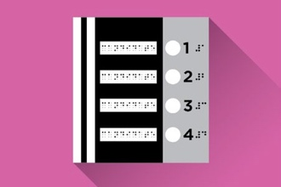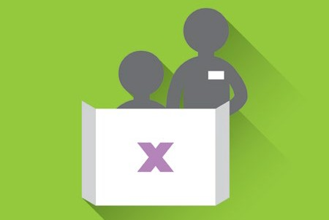

##### Voting with a Difference 39

Most of these tools and services are available for you if you vote on election day, on advance polling days, and at your Elections Canada   
office. Note that the braille lists of candidates are only available for   
voting on election day.

## Assistance marking your ballot:

Election workers can assist you if you need help marking your ballot.   
In this case, a second election worker will always be present to act   
as a witness.

If someone helps you mark your ballot:

1. The person helping you will ask you which candidate you wish   
   to vote for. They will mark the ballot on your behalf, behind the   
   voting screen.
2. The person will ask you if you want to put the ballot in the ballot box yourself, or if you want them to do it for you.

## Language or sign language interpretation:

If you need language or sign language interpretation on election day, you may either bring your own interpreter, or request that Elections Canada provide one. If you would like Elections Canada to provide one, they need to know by 6:00 PM on the Tuesday before election day.

Once the election is called, contact Elections Canada to let them know what type of interpretation service you need. There are a few ways to do this:

* Fill out the form [**here**](https://secure.elections.ca/FeedbackQuestion.aspx?lang=e) at elections.ca
* Call at 1-800-463-6868
* TTY at 1-800-361-8935

## Accessibility of my polling station or Elections Canada office:

Many people have found it challenging to get into and make   
their way around the building where their polling station is located.

Elections Canada has developed 15 mandatory criteria to make sure regular and advance polling stations are physically suitable

for voters. **See on page 27**. Most polling stations and   
Elections Canada offices meet all the criteria.

## For doors without automatic openers:

If the exterior door or interior doors of the polling station don’t have automatic door openers, an election officer will provide assistance if needed. Please let this person know how they can help.

If you are unable to vote without difficulty at your polling station because it won’t have the features you need, you can apply for a transfer certificate. This will allow you to vote at another polling station in the same riding. Call your Elections Canada office for more information.

Find the contact information for your Elections Canada office:

[**Voter Information Service**](https://www.elections.ca/scripts/vis/FindED?L=e&amp;PAGEID=20), or call 1-800-463-6868 / TTY 1-800-361-8935.

# Bringing my own supports for voting

## Bring your own device:

You can also bring your own assistive device, such as your own pencil to mark the ballot, or a personal mobile device, such as a smart phone, to read the ballot behind the voting screen.

## Bring your service animal:

You may bring your service animal to assist you when you vote. In some rare cases, local laws may regulate the presence of service animals in public spaces. If you believe your service animal may not be permitted in your polling station, contact your Elections Canada local office to explore solutions.

## Bring a support person for help marking your ballot:

If you need help to mark your ballot, you can bring a support person (such as a family member, friend, or personal support worker) to help you vote. To protect the secrecy of your vote, this person will be asked to make a declaration before you vote.

If this person is your relative, spouse or common-law partner, or a relative of your spouse or common-law partner:

* They don’t have to be a Canadian citizen 18 years old or older. They do not have to be eligible to vote.
* They can help more than one family member to vote. (They can also help one non-family member)

If this person is a friend or other person you trust like a support worker or sign-language interpreter:

* They don’t have to be a Canadian citizen 18 years old or older. They do not have to be eligible to vote.
* They will have to make a declaration to make sure they respect the secrecy of your vote.
* This friend or other supporter can only help one person to vote.

If you are bringing your own interpreter, this person will need to make a declaration to make sure they respect the secrecy of your vote.

1. An election worker will give the declaration
2. The interpreter does not have to be a voter and may help more than one voter

## Help to prove your identity:

If you don’t have all the ID you need, someone can vouch for you to help prove your identity and address. This person must be an eligible elector assigned to the same polling station as you, and may vouch for the identity and address of only one person.

At a senior’s residence or institution serving persons with a disability, an employee of that institution may vouch for the identity and address

of more than one elector, including any elector who resides in that riding   
or a riding nearby.

# How do I make a plan to vote?

Watch this video made by Elections Canada to [**make a plan to vote**](https://www.elections.ca/content2.aspx?section=spr&amp;dir=voting&amp;document=vidmkplan&amp;lang=e). You could also use this checklist to help you make your plan to vote:

## Voter’s checklist

Make sure you’re registered at your current address

At your assigned polling station on election day

Watch for your voter information card in the mail

At your assigned polling station on advance polling days

Make a plan to vote

At any Elections Canada office across Canada (deadlines apply)

Find out who the candidates are in your riding

By mail: visit elections.ca to find out more (deadlines apply)

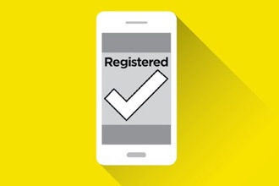

Bring ID when you go to vote

##### Voting with a Difference 44

## Things to consider when making your plan to vote:

1. **CHOOSE:** Which way to vote works best for you? When can you go   
   to vote?
2. **MAKE SURE:** Will the ***exterior*** of the polling station meet your needs? For example, do you have any concerns about the slope of the pathway or sidewalk to the entrance, or about curb cuts, a ramp or signage outside? Will the ***entrance*** of the polling station meet your needs, such as with easy to grip door handles, an automatic door opener or immediate access to the voting room from the entrance door? Will the ***interior features*** of the polling station meet your needs, such as an elevator, a level access ramp to access the voting room, or an accessible washroom? Will you have the ***other supports*** you will need so you can vote, such as help from someone or technical aids? Explore your polling station or call Elections Canada to confirm whether your polling station will meet your needs
3. **SCHEDULE:** How will you get to your polling station to vote?
   1. What types of public transit are available? Is there a stop near your polling station?
   2. What route will you take to get to your polling station? Will there be traffic to consider?
   3. Will you need to make special arraignments to get to your polling station?
4. **CHECK:** If you or someone else will be driving you to your polling station, does it have parking? Does it have a space reserved for persons with disabilities if you’ll need this? Is there a pathway from the parking to the entrance of the polling station? Explore your polling station or call Elections Canada to confirm whether your polling station will meet   
   your needs.
5. **DECIDE:** Find more information about the candidates in your riding through the [**Voter Information Service**](https://www.elections.ca/scripts/vis/FindED?L=e&amp;PAGEID=20). Decide who you are going  
   to vote for.
6. **BRING:** Do you have the right pieces of identification to prove your   
   name and address? Do you have an assistive device that can help you vote? Is there someone you trust available to go with you to vote?

##### VOTE!

1. **SHARE:** Now that you’ve voted, what was it like? Share feedback   
   on your voting experience with Elections Canada to help improve   
   their services.

* Complete the online [**Complaint form**](https://secure.elections.ca/Complaints.aspx?lang=e).
* Complete the online [**Accessibility Feedback form**](https://secure.elections.ca/SiteFeedback.aspx?lang=e)or complete the form at your polling station.
* Speak with an election worker when you go to vote.
* Contact by telephone — Monday to Friday, from 9:00 a.m. to 5:00 p.m. (Eastern Time)   
  1-800-463-6868 / (TTY) 1-800-361-8935

# How do I find more information about voting?

#### Elections Canada has many resources to help you learn about voting in federal elections.

If a family member or friend is incarcerated in a correctional institution or federal penitentiary, they can vote in the general election. Information is available at [**Voting by Incarcerated Electors**](https://www.elections.ca/content.aspx?section=vot&amp;dir=bkg&amp;document=ec90545&amp;lang=e).

[**Spread the Word**](https://www.elections.ca/content2.aspx?section=spr&amp;document=index&amp;lang=e) — tools you can download and share to spread the word about the election**.**

Some of these tools are available in braille, large print and audio formats. Some of these tools are also translated into languages other than English and French. These tools are:

##### [The Guide to the Federal Election](https://www.elections.ca/content2.aspx?section=spr&amp;dir=voting&amp;document=guige&amp;lang=e)

##### [Full list of accepted ID to register and vote](https://www.elections.ca/content2.aspx?section=id&amp;dir=idLangs&amp;document=index&amp;lang=e)

##### [Get Ready to Vote flyer](https://www.elections.ca/content2.aspx?section=spr&amp;dir=voting&amp;document=pre&amp;lang=e)

To order these products in accessible formats, contact Elections Canada:

* Use the [**online enquiry form**](https://secure.elections.ca/FeedbackQuestion.aspx?lang=e)
* Contact by telephone — Monday to Friday, from 9:00 a.m.

to 5:00 p.m. (Eastern Time) 1-800-463-6868 / (TTY) 1-800-361-8935

* Contact by Video Relay Services for users of SRV [**Canada VRS**](https://srvcanadavrs.ca/)
* Contact by fax — 613-954-8584 / 1-888-524-1444 (toll-free in Canada and the United States)
* Contact by e-mail — [**info@elections.ca**](mailto:info@elections.ca)

##### Check out the [Inspire Democracy Elector’s Guidebook to Registering](http://inspirerlademocratie-inspiredemocracy.ca/act/regist/rgvot/index-eng.asp) [and Voting](http://inspirerlademocratie-inspiredemocracy.ca/act/regist/rgvot/index-eng.asp)

# How do I find more information about accessibility and elections?

##### Accessibility policy and service offering

##### Polling place suitability checklist

##### [Information about Accessible Polling Stations](https://www.elections.ca/content2.aspx?section=acc&amp;dir=pol&amp;document=index&amp;lang=e)

##### [Voting Tools and Services](https://www.elections.ca/content2.aspx?section=acc&amp;dir=tol&amp;document=index&amp;lang=e&amp;cid)

##### [Video: Voting assistance tools and services on election day](https://www.elections.ca/content2.aspx?section=spr&amp;dir=voting&amp;document=vidvts&amp;lang=e)

##### [Video: Voting assistance tools and services on election day — ASL](https://www.elections.ca/content2.aspx?section=spr&amp;dir=voting&amp;document=vidvts_asl&amp;lang=e)

##### [Video: Making the federal election accessible](https://www.elections.ca/content2.aspx?section=spr&amp;dir=voting&amp;document=vidmfea&amp;lang=e)

##### [Video: Making the federal election accessible — ASL](https://www.elections.ca/content2.aspx?section=spr&amp;dir=voting&amp;document=vidmfea_asl&amp;lang=e)

# How do I contact Elections Canada?

* Complete the online [**Complaint form**](https://secure.elections.ca/Complaints.aspx?lang=e).
* Complete the online [**Accessibility Feedback form**](https://secure.elections.ca/SiteFeedback.aspx?lang=e) or complete the form at your polling station.
* Speak with an election worker when you go to vote.
* Contact by telephone — Monday to Friday, from 9:00 a.m. to   
  5:00p.m. (Eastern Time)
  + 1-800-463-6868 (toll-free in Canada and the United States)
  + 001-800-514-6868 (toll-free in Mexico)
  + 613-993-2975 (from anywhere in the world)
* Contact by TTY–Monday to Friday, from 9:00 a.m. to 5:00 p.m. (Eastern Time) 1-800-361-8935 (toll-free in Canada and the United States)
* Contact by Video Relay Services for users of SRV [**Canada VRS**](https://srvcanadavrs.ca/)
* Contact by fax — 613-954-8584 / 1-888-524-1444 (toll-free in Canada and the United States)
* Contact by e-mail — [**info@elections.ca**](mailto:info@elections.ca)
* Message Elections Canada on [**social media**](http://www.elections.ca/content.aspx?section=cont&amp;dir=soc&amp;document=index&amp;lang=e)

# Key terms

## Advance polling station

An advance polling station is a polling station where you can vote before election day. They will be open between noon and 8 p.m. on Friday, Saturday, Sunday and Monday, the 10th, 9th, 8th and 7th days before election day. Your voter information card will tell you where your advance polling station is located and the dates and hours it will be open.

## Ballot: Regular

A regular ballot is a piece of paper that shows the names of the candidates, their political parties and a place for you to indicate the candidate you want to vote for.

## Ballot: Special

A special ballot is a piece of paper with a space where you write the name of the candidate you want to vote for. The candidates’ names and political parties are not already printed on the ballot. You will use the special ballot to vote by mail. You will also use the special ballot if you vote at an Elections Canada office or if you vote at home earlier than two weeks before election day.

## Candidate

A candidate is a person who is running for an elected position. Often this person is a member of a political party, which is a group of people who have the same vision about how the country should be governed.

## Declaration

A declaration is a written statement that you sign, giving information or saying that something is true, such as your name and address.

## Elections Canada office

After an election is called, Elections Canada sets up offices in every riding across Canada. To find out the location, hours of operation and contact information for your Elections Canada office after the election has been called, you can visit the online [**Voter Information Service**](https://www.elections.ca/scripts/vis/FindED?L=e&amp;PAGEID=20) or you   
can call 1-800-463-6868 / TTY 1-800-361-8935.

## Elector

A person who is a Canadian citizen at least 18 years old, and therefore eligible   
to vote.

## House of Commons

It’s the group of political leaders elected by Canadians to make decisions about how Canada will be run as a country. They regularly meet in Parliament to discuss and make decisions about the country’s affairs.   
It’s also one of the Parliament buildings in Ottawa, where the elected   
political leaders meet.

## Letter of Confirmation of Residence

This is a letter that can be used as your proof of address — along with a second piece of ID — to register and vote in a federal election. This proof   
of address will be valid only if it is signed by the administrator of

a student residence, seniors’ residence, long-term care facility, shelter,   
soup kitchen, First Nations’ band or reserve, or Inuit local authority   
where you live or receive services. The facility must be listed with   
Elections Canada or else the letter will not be accepted at the polls.

## Polling station

A polling station is where people go to vote. Each voter is assigned to a   
polling station that depends on where they live. If you didn’t receive your   
voter information card or misplaced it, you can find your polling station   
at the online [**Voter Information Service**](https://www.elections.ca/scripts/vis/FindED?L=e&amp;PAGEID=20) or you can call 1-800-463-6868 /   
TTY 1-800-361-8935. You’ll need your postal code to find a polling station   
close to you.

## Riding

A riding is the same as an “electoral district”. It’s an area of geography represented by a member of the House of Commons. A riding could have   
several polling divisions within it.

## Transfer certificate

A certificate allows you to vote at another, more accessible polling station in your riding if the polling station you were originally assigned is inaccessible to you.   
You apply to Elections Canada for a transfer certificate.

## Voter information card

The voter information card is a card that Elections Canada will mail

to you after you’ve registered to vote. Your voter information card will show your name and address, where you can vote, and the dates and hours your regular and advance polling stations will be open. It tells you about the physical accessibility of the place where you will vote with an accessibility symbol, can help speed up voting and can be used as one of two pieces   
of ID to vote.

## Vouch

To vouch is to be able, from your knowledge or experience, to say that something is true, such as when you tell someone the name and address   
of a person you know.